## Updated MR inheritance + competition + MR scale (removed initial rescale, converted all to 0-1) – Recruitment 0.003

|  |  |  |
| --- | --- | --- |
|  | | |
| age_impact = 1.0  MR_death_impact = F  MR_lateintro = F  recruitment_const = 0.003  comp_impact = 0.9 |  |  |
| age_impact = 1.0  MR_death_impact = 0.05  MR_lateintro = F  recruitment_const = 0.003  comp_impact = 0.9 |  |  |
|  |  |  |
| age_impact = 1.0  MR_death_impact = 0.1  MR_lateintro = F  recruitment_const = 0.003  comp_impact = 0.9 |  |  |
| age_impact = 1.0  MR_death_impact = 0.1  MR_lateintro = T - 2000  recruitment_const = 0.003  comp_impact = 0.9 |  |  |
| age_impact = 1.0  MR_death_impact = 0.15  MR_lateintro = F  recruitment_const = 0.003  comp_impact = 0.9 |  |  |
| age_impact = 1.0  MR_death_impact = 0.2  MR_lateintro = F  recruitment_const = 0.003  comp_impact = 0.9 |  |  |
| age_impact = 1.0  MR_death_impact = 0.2  MR_lateintro = T - 2000  recruitment_const = 0.003  comp_impact = 0.9 |  |  |
| age_impact = 1.0  MR_death_impact = 0.5  MR_lateintro = F  recruitment_const = 0.003  comp_impact = 0.9 |  |  |
| age_impact = 1.0  MR_death_impact = 0.5  MR_lateintro = T - 2000  recruitment_const = 0.003  comp_impact = 0.9 |  |  |

|  |  |  |
| --- | --- | --- |
| Pop 1  Age imp val = 1.0  MR imp val = 0.5  Pop 2  Age imp val = 1.0  MR imp val = 0.05 | Blue = runs without maladaptation events (running it solo)  Red = runs with maladaptation events (running both pops in conjunction)  Where for each side pop 1, maladapts with pop 2 (triangle events)  For the left side, pop 1, the maladapted pop is brought higher with the influence of pop2  For the right side, the population is |  |

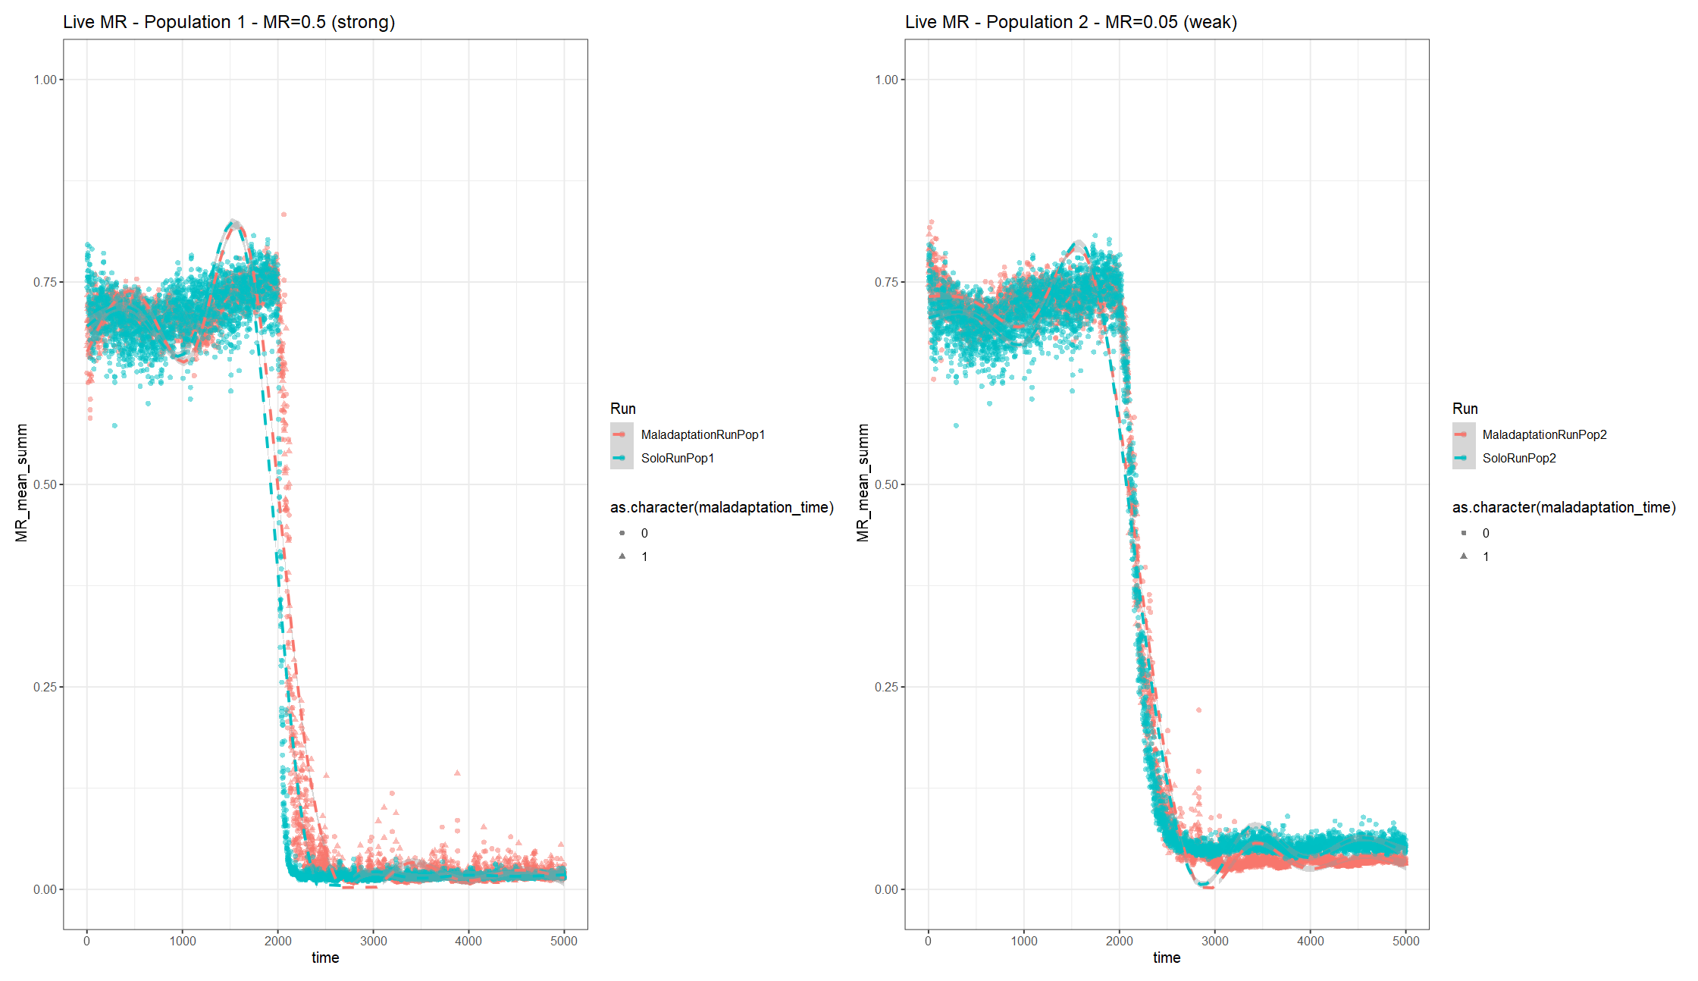

## Change MR recruitment to ^2 instead of ^4; adjust MR inheritance by -0.08

|  |  |  |
| --- | --- | --- |
| age_impact = 1.0  MR_death_impact = F  MR_lateintro = F  recruitment_const = 0.003  comp_impact = 0.9 |  |  |
| age_impact = 1.0  MR_death_impact = 0.1  MR_lateintro = T - 1000  recruitment_const = 0.003  comp_impact = 0.9 |  |  |
| age_impact = 1.0  MR_death_impact = 0.2  MR_lateintro = T - 1000  recruitment_const = 0.003  comp_impact = 0.9 |  |  |
|  |  |
| T=2000 |  |  |
|  |  |
| age_impact = 1.0  MR_death_impact = 0.5  MR_lateintro = F  recruitment_const = 0.003  comp_impact = 0.9 |  |  |
| age_impact = 1.0  MR_death_impact = 0.5  MR_lateintro = T - 1000  recruitment_const = 0.003  comp_impact = 0.9 |  |  |
| age_impact = 1.0  MR_death_impact = 0.75  MR_lateintro = T - 1000  recruitment_const = 0.003  comp_impact = 0.9 |  |  |
| age_impact = 1.0  MR_death_impact = 0.8  MR_lateintro = T - 2000  recruitment_const = 0.003  comp_impact = 0.9 |  |  |
| age_impact = 1.0  MR_death_impact = 1.0  MR_lateintro = T - 1000  recruitment_const = 0.003  comp_impact = 0.9 |  |  |
|  |  |
| Pop 1  Age imp val = 1.0  MR imp val = 0.2  Pop 2  Age imp val = 1.0  MR imp val = 0.8 | Was run without maladaptation at the start to confirm initial pops overlapped  Q: Why does it drop at the start? |  |

## Change MR recruitment to ^2 instead of ^4

|  |  |  |
| --- | --- | --- |
| Pop 1  age_impact = 1.0  MR_death_impact = 0.5  MR_lateintro = T - 2000  recruitment_const = 0.003  comp_impact = 0.9 |  |  |
| Pop 2  age_impact = 1.0  MR_death_impact = 0.05  MR_lateintro = T - 2000  recruitment_const = 0.003  comp_impact = 0.9 |  |  |
| Pop 1  Age imp val = 1.0  MR imp val = 0.5  Pop 2  Age imp val = 1.0  MR imp val = 0.05 | Blue = runs without maladaptation events (running it solo)  Red = runs with maladaptation events (running both pops in conjunction)  Where for each side, red, pop 1, maladapts with pop 2 (triangle events):   * For the left side, pop 1, the maladapted pop is **pulled up** with the influence of pop2 (less resistant) * For the right side, pop 2 is **pulled** **down** with the influence of pop1 (more resistant) |  |

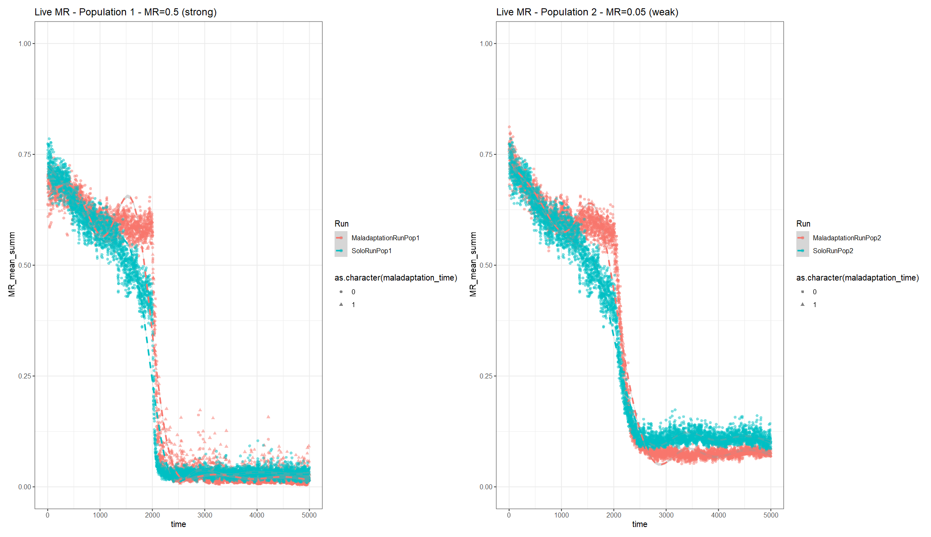

|  |  |  |  |  |  |
| --- | --- | --- | --- | --- | --- |
| Impact _ MR | 0.10 | 0.12 | 0.14 | 0.16 | 0.18 |
|  |  |  |  |  |  |
|  |  |  |  |  |  |
|  |  |  |  |  |  |

**Adjusted recruitment to account for MR and age**

|  |  |
| --- | --- |
|  |  |

### Intervention

Data_sim_3

Altered mortality – age of interception indivs *4 until mortality_age_shift/4 (~35)

#### Base:

* Recruitment adjustment = 0 & ^2
* MR=0.12
* MR introduced at 1000

#### Intervention_100-0.15-0.1_T1025:

* Population size = 1000
* Init pop MR mean= 0.787; MR sd=0. 385
* Recruitment adjustment = 0 & ^2
* MR=0.12
* MR introduced at 1000
* intercept_timepoint = 1025
* Dropped mean MR from 0.4468093 -> 0.4385565
* intercept_indiv = 100
* intercept_MR_mean = 0.15
* intercept_MR_sd = 0.1

# A tibble: 2 × 2

Run min_pop_size

*<chr>* *<dbl>*

1 Base 1362.

2 Resistance Intervention 1598.

#### Intervention_300-0.15-0.1_T1025:

* Population size = 1000
* Init pop MR mean= 0.787; MR sd=0. 385
* Recruitment adjustment = 0 & ^2
* MR=0.12
* MR introduced at 1000
* intercept_timepoint = 1025
  + Dropped mean MR from 0.4468093 -> 0.4235052
* intercept_indiv = 300
* intercept_MR_mean = 0.15
* intercept_MR_sd = 0.1

# A tibble: 2 × 2

Run min_pop_size

*<chr>* *<dbl>*

1 Base 1362.

2 Resistance Intervention 1222.

#### Intervention_300-0.10-0.05_T1025:

* Population size = 1000
* Init pop MR mean= 0.787; MR sd=0. 385
* Recruitment adjustment = 0 & ^2
* MR=0.12
* MR introduced at 1000
* intercept_timepoint = 1025
  + Dropped mean MR from 0.499 -> 0.4718
* intercept_indiv = 300
* intercept_MR_mean = 0.10
* intercept_MR_sd = 0.05

# A tibble: 2 × 2

Run min_pop_size

*<chr>* *<dbl>*

1 Base 1362.

2 Resistance Intervention 1470.

#### Intervention_300-0.15-0.10_T1050:

* Population size = 1000
* Init pop MR mean= 0.787; MR sd=0. 385
* Recruitment adjustment = 0 & ^2
* MR=0.12
* MR introduced at 1000
* intercept_timepoint = 1050
  + Dropped mean MR from 0.4458399 -> 0.4202595
* intercept_indiv = 300
* intercept_MR_mean = 0.15
* intercept_MR_sd = 0.10

> live_size_wind_mean %>%

+ group_by(Run) %>%

+ summarise(min_pop_size = min(mean_wind_size))

# A tibble: 2 × 2

Run min_pop_size

*<chr>* *<dbl>*

1 Base 1362.

2 Resistance Intervention 1367.

#### Intervention_300-0.15-0.10_T1025:

* Population size = 1000
* Init pop MR mean= 0.787; MR sd=0. 385
* Recruitment adjustment = 0 & ^2
* MR=0.12
* MR introduced at 1000
* intercept_timepoint = 1025
  + Dropped mean MR from 0.4468093 -> 0.4235052
* intercept_indiv = 300
* intercept_MR_mean = 0.15
* intercept_MR_sd = 0.1

# A tibble: 2 × 2

Run min_pop_size

*<chr>* *<dbl>*

1 Base 1362.

2 Resistance Intervention 1192.

#### Intervention_500-0.15-0.10_T1025:

* Population size = 1000
* Init pop MR mean= 0.787; MR sd=0. 385
* Recruitment adjustment = 0 & ^2
* MR=0.12
* MR introduced at 1000
* intercept_timepoint = 1025
  + Dropped mean MR from 0.4468093 -> 0.4102694
* intercept_indiv = 500
  + After addition (*N =* 4035)
* intercept_MR_mean = 0.15
* intercept_MR_sd = 0.1

# A tibble: 2 × 2

Run min_pop_size

*<chr>* *<dbl>*

1 Base 1362.

2 Resistance Intervention 1635.

#### Intervention_1000-0.15-0.1_T1025:

* Population size = 1000
* Init pop MR mean= 0.787; MR sd=0. 385
* Recruitment adjustment = 0 & ^2
* MR=0.12
* MR introduced at 1000
* intercept_timepoint = 1025
  + Dropped mean MR from 0.4468093 -> 0.3825454
* intercept_indiv = 1000
  + After addition (*N =* 4535)
* intercept_MR_mean = 0.15
* intercept_MR_sd = 0.1

# A tibble: 2 × 2

Run min_pop_size

*<chr>* *<dbl>*

1 Base 1362.

2 Resistance Intervention 1845.

#### Intervention_300-0.15-0.1_T1025_PopSize4000:

* Population size = 4000
* Init pop MR mean= 0.787; MR sd=0. 385
* Recruitment adjustment = 0 & ^2
* MR=0.12
* MR introduced at 1000
* intercept_timepoint = 1025
  + Dropped mean MR from 0.4468093 -> 0.3825454
* intercept_indiv = 300
* intercept_MR_mean = 0.15
* intercept_MR_sd = 0.1

# A tibble: 2 × 2

Run min_pop_size

*<chr>* *<dbl>*

1 Base 6280.

2 Resistance Intervention 7039.

**Reducing recruitment: to 0.0025 from 0.003**

#### Intervention_300-0.15-0.1_T1025 _ResistInitMR:

* Population size = 1000
* Init pop MR mean= 0.25; MR sd=0. 1
* Recruitment adjustment = 0 & ^2
* MR=0.12
* MR introduced at 1000
* intercept_timepoint = 1025
  + Dropped mean MR from 0.243588 -> 0.2376324
* intercept_indiv = 300
* intercept_MR_mean = 0.15
* intercept_MR_sd = 0.1

> live_size_wind_mean %>%

+ group_by(Run) %>%

+ summarise(min_pop_size = min(mean_wind_size))

# A tibble: 2 × 2

Run min_pop_size

*<chr>* *<dbl>*

1 Base 2011.

2 Resistance Intervention 2485.

E.g., 0.3 recruit

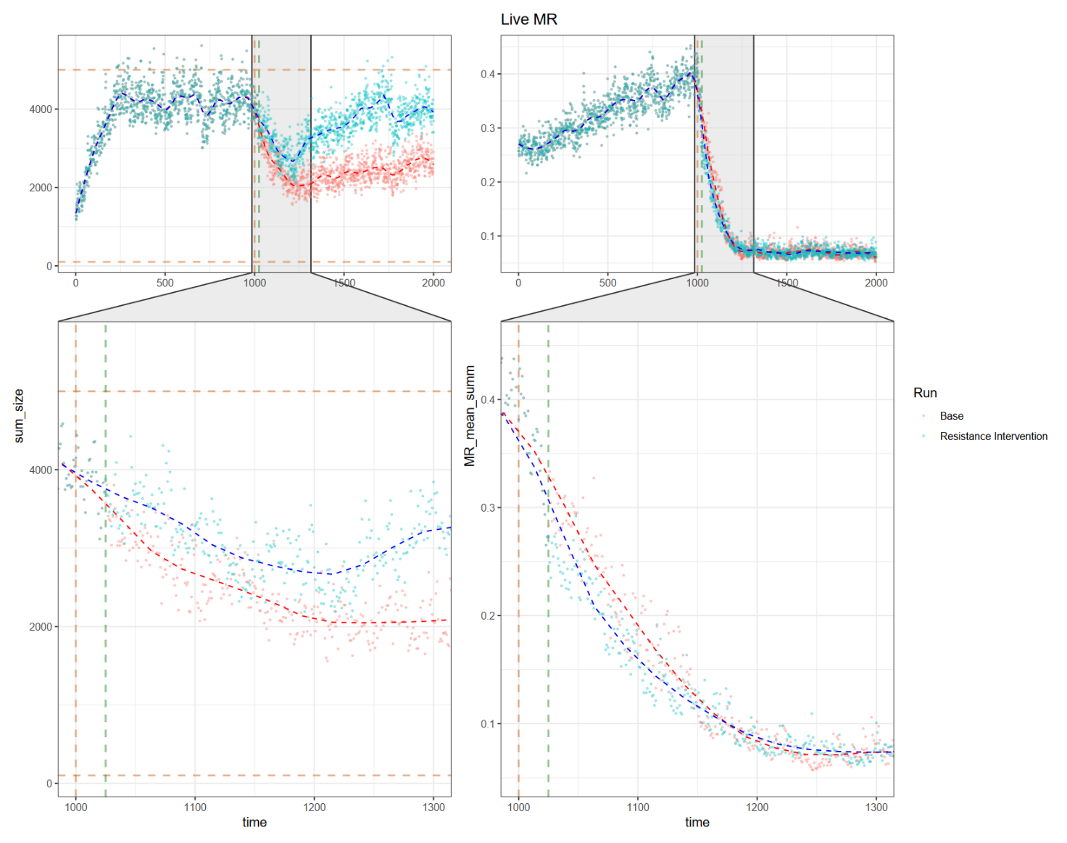

#### Intervention_300-0.15-0.1_T1025_Rm mortality reduction_ ResistInitMR:

* Population size = 1000
* Init pop MR mean= 0.25; MR sd=0. 1
* Recruitment adjustment = 0 & ^2
* MR=0.12
* MR introduced at 1000
* intercept_timepoint = 1025
  + Dropped mean MR from 0.2764773 -> 0.2684228
* intercept_indiv = 300
* intercept_MR_mean = 0.15
* intercept_MR_sd = 0.1
* intercept_reducMort = F

# A tibble: 2 × 2

Run min_pop_size

*<chr>* *<dbl>*

1 Base 1362.

2 Resistance Intervention 1845.

#### Intervention_300-0.8-0.1_T1050:

* Population size = 1000
* Init pop MR mean= 0.787; MR sd=0. 385
* Recruitment adjustment = 0 & ^2
* MR=0.12
* MR introduced at 1000
* intercept_timepoint = 1050
  + Mean MR from 0.4468093 -> 0.4741063
* intercept_indiv = 300
* intercept_MR_mean = 0.80
* intercept_MR_sd = 0.10
* intercept_reducMort = F

> live_size_wind_mean %>%

+ group_by(Run) %>%

+ summarise(min_pop_size = min(mean_wind_size))

# A tibble: 2 × 2

Run min_pop_size

*<chr>* *<dbl>*

1 Base 1362.

2 Resistance Intervention 1330.

## Change MR recruitment to adjust for MR and age; MR recruited return back to ^4

**Base**

|  |  |  |
| --- | --- | --- |
| ## Input parameters for high MR pressure sites  ## Population parameters  population_size = 1000  population_carrying_capacity = population_size*5  population_minimum_size = population_size/10  MR_mean = 0.787 # From actual genotype data  MR_sd = 0.385  disturbance_impact_val=5 # impacts base age & MR death factor and recruitment constant  ## Mortality parameters  age_impact = 1.0 # scaled age inflicted increase - from 0 to 1, should add to 1 with MR impact val  mortality_age_shift = 150 # at what age does increases in age increase chance of death  MR_imp = T # toggle on/off for MR inflicted death increase  MR_death_impact = 0.20 # linear scaled MR inflicted death increase - from 0 to 1, should add to 1 with age impact val  MR_age_impact = 20 # scaled impact of age (ages / MR_age_impact_val) on MR inflicted death increase  MR_lateintro = T  MR_timepoint = 1000 # time point when MR is introduced  ## Recruitment parameters  recruitment_const = 0.003 # base constant for chance of recruitment  recruitment_age = 7 # age to begin recruiting  recruitment_mean = 100 # mean for PDF of normal distribution for number of recruited individuals  recruitment_sd = recruitment_mean/2 # standard deviation of number of recruited individuals  age_rec_toggle = TRUE # Takes the complimentary of the age fraction to reduce recruitment mean according to size (larger = closer to 1)  age_recruit_impact_value = 0.5 # Range from 0.01-1. Takes the exponential of this value, the higher this value, the steeper the penalisation  rec_age_shift = 100 # age shift, lower than this age recruitment for the individual is penalised  MR_rec_toggle = F # toggle on/off of MR affect on recruitment  MR_recruit_impact = 0.5 # impact of MR on recruitment, a multiplier of the individual MR to reduce recruitment chance  MR_rec_adj = 0 # Shift mean of MR status of recruited individuals  ## Intervention parameters  intercept_togg = F |  |  |
| ## Input parameters for high MR pressure sites  ## Population parameters  population_size = 1000  population_carrying_capacity = population_size*5  population_minimum_size = population_size/10  MR_mean = 0.787 # From actual genotype data  MR_sd = 0.385  disturbance_impact_val=5 # impacts base age & MR death factor and recruitment constant  ## Mortality parameters  age_impact = 1.0 # scaled age inflicted increase - from 0 to 1, should add to 1 with MR impact val  mortality_age_shift = 150 # at what age does increases in age increase chance of death  MR_imp = T # toggle on/off for MR inflicted death increase  MR_death_impact = 0.12 # linear scaled MR inflicted death increase - from 0 to 1, should add to 1 with age impact val  MR_age_impact = 20 # scaled impact of age (ages / MR_age_impact_val) on MR inflicted death increase  MR_lateintro = T  MR_timepoint = 1000 # time point when MR is introduced  ## Recruitment parameters  recruitment_const = 0.003 # base constant for chance of recruitment  recruitment_age = 7 # age to begin recruiting  recruitment_mean = 100 # mean for PDF of normal distribution for number of recruited individuals  recruitment_sd = recruitment_mean/2 # standard deviation of number of recruited individuals  age_rec_toggle = TRUE # Takes the complimentary of the age fraction to reduce recruitment mean according to size (larger = closer to 1)  age_recruit_impact_value = 0.5 # Range from 0.01-1. Takes the exponential of this value, the higher this value, the steeper the penalisation  rec_age_shift = 100 # age shift, lower than this age recruitment for the individual is penalised  MR_rec_toggle = F # toggle on/off of MR affect on recruitment  MR_recruit_impact = 0.5 # impact of MR on recruitment, a multiplier of the individual MR to reduce recruitment chance  MR_rec_adj = 0 # Shift mean of MR status of recruited individuals  ## Intervention parameters  intercept_togg = F |  |  |
| ## Input parameters for high MR pressure sites  ## Population parameters  population_size = 1000  population_carrying_capacity = population_size*5  population_minimum_size = population_size/10  MR_mean = 0.787 # From actual genotype data  MR_sd = 0.385  disturbance_impact_val=5 # impacts base age & MR death factor and recruitment constant  ## Mortality parameters  age_impact = 1.0 # scaled age inflicted increase - from 0 to 1, should add to 1 with MR impact val  mortality_age_shift = 150 # at what age does increases in age increase chance of death  MR_imp = T # toggle on/off for MR inflicted death increase  MR_death_impact = 0.12 # linear scaled MR inflicted death increase - from 0 to 1, should add to 1 with age impact val  MR_age_impact = 20 # scaled impact of age (ages / MR_age_impact_val) on MR inflicted death increase  MR_lateintro = T  MR_timepoint = 1000 # time point when MR is introduced  ## Recruitment parameters  recruitment_const = 0.003 # base constant for chance of recruitment  recruitment_age = 7 # age to begin recruiting  recruitment_mean = 100 # mean for PDF of normal distribution for number of recruited individuals  recruitment_sd = recruitment_mean/2 # standard deviation of number of recruited individuals  age_rec_toggle = TRUE # Takes the complimentary of the age fraction to reduce recruitment mean according to size (larger = closer to 1)  age_recruit_impact_value = 0.5 # Range from 0.01-1. Takes the exponential of this value, the higher this value, the steeper the penalisation  rec_age_shift = 100 # age shift, lower than this age recruitment for the individual is penalised  MR_rec_toggle = F # toggle on/off of MR affect on recruitment  MR_recruit_impact = 0.5 # impact of MR on recruitment, a multiplier of the individual MR to reduce recruitment chance  MR_rec_adj = 0 # Shift mean of MR status of recruited individuals  ## Intervention parameters  intercept_togg = F  ## Disturbance parameters (ranges from super small to big impacts)  **dist_imp = F # Turn on and off disturbance presence** |  |  |
| ## Input parameters for high MR pressure sites  ## Population parameters  population_size = 1000  population_carrying_capacity = population_size*5  population_minimum_size = population_size/10  MR_mean = 0.787 # From actual genotype data  MR_sd = 0.385  disturbance_impact_val=5 # impacts base age & MR death factor and recruitment constant  ## Mortality parameters  age_impact = 1.0 # scaled age inflicted increase - from 0 to 1, should add to 1 with MR impact val  mortality_age_shift = 150 # at what age does increases in age increase chance of death  MR_imp = T # toggle on/off for MR inflicted death increase  MR_death_impact = 0.12 # linear scaled MR inflicted death increase - from 0 to 1, should add to 1 with age impact val  MR_age_impact = 20 # scaled impact of age (ages / MR_age_impact_val) on MR inflicted death increase  MR_lateintro = T  MR_timepoint = 1000 # time point when MR is introduced  ## Recruitment parameters  recruitment_const = 0.003 # base constant for chance of recruitment  recruitment_age = 7 # age to begin recruiting  recruitment_mean = 100 # mean for PDF of normal distribution for number of recruited individuals  recruitment_sd = recruitment_mean/2 # standard deviation of number of recruited individuals  age_rec_toggle = TRUE # Takes the complimentary of the age fraction to reduce recruitment mean according to size (larger = closer to 1)  age_recruit_impact_value = 0.5 # Range from 0.01-1. Takes the exponential of this value, the higher this value, the steeper the penalisation  rec_age_shift = 100 # age shift, lower than this age recruitment for the individual is penalised  MR_rec_toggle = F # toggle on/off of MR affect on recruitment  **MR_recruit_impact = 0.75 # impact of MR on** recruitment, a multiplier of the individual MR to reduce recruitment chance  MR_rec_adj = 0 # Shift mean of MR status of recruited individuals  ## Intervention parameters  intercept_togg = F  ## Disturbance parameters (ranges from super small to big impacts)  dist_imp = F # Turn on and off disturbance presence |  |  |

**Intervention**

|  |  |
| --- | --- |
| ## Input parameters for high MR pressure sites  ## Population parameters  population_size = 1000  population_carrying_capacity = population_size*5  population_minimum_size = population_size/10  MR_mean = 0.787 # From actual genotype data  MR_sd = 0.385  disturbance_impact_val=5 # impacts base age & MR death factor and recruitment constant  ## Mortality parameters  age_impact = 1.0 # scaled age inflicted increase - from 0 to 1, should add to 1 with MR impact val  mortality_age_shift = 150 # at what age does increases in age increase chance of death  MR_imp = T # toggle on/off for MR inflicted death increase  MR_death_impact = 0.12 # linear scaled MR inflicted death increase - from 0 to 1, should add to 1 with age impact val  MR_age_impact = 20 # scaled impact of age (ages / MR_age_impact_val) on MR inflicted death increase  MR_lateintro = T  MR_timepoint = 1000 # time point when MR is introduced  ## Recruitment parameters  recruitment_const = 0.003 # base constant for chance of recruitment  recruitment_age = 7 # age to begin recruiting  recruitment_mean = 100 # mean for PDF of normal distribution for number of recruited individuals  recruitment_sd = recruitment_mean/2 # standard deviation of number of recruited individuals  age_rec_toggle = TRUE # Takes the complimentary of the age fraction to reduce recruitment mean according to size (larger = closer to 1)  age_recruit_impact_value = 0.5 # Range from 0.01-1. Takes the exponential of this value, the higher this value, the steeper the penalisation  rec_age_shift = 100 # age shift, lower than this age recruitment for the individual is penalised  MR_rec_toggle = F # toggle on/off of MR affect on recruitment  MR_recruit_impact = 0.5 # impact of MR on recruitment, a multiplier of the individual MR to reduce recruitment chance  MR_rec_adj = 0 # Shift mean of MR status of recruited individuals  ## Intervention parameters  intercept_togg = T  intercept_timepoint = 1025  intercept_indiv = 300  intercept_MR_mean = 0.15 # (bottom third)  intercept_MR_sd = 0.1  intercept_reducMort = T | MR mean 0.6943643 -> 0.6597317  # A tibble: 2 × 2  Run min_pop_size  <chr> <dbl>  1 Base 1447.  2 Resistance Intervention 1383. |
| ## Intervention parameters  intercept_togg = T  intercept_timepoint = 1025  intercept_indiv = 300  intercept_MR_mean = 0.75 # (top quarter)  intercept_MR_sd = 0.1  intercept_reducMort = T | MR 0.567441 -> 0.5811666 |
| ## Input parameters for high MR pressure sites  ## Population parameters  population_size = 1000  population_carrying_capacity = population_size*5  population_minimum_size = population_size/10  MR_mean = 0.787 # From actual genotype data  MR_sd = 0.385  disturbance_impact_val=5 # impacts base age & MR death factor and recruitment constant  ## Mortality parameters  age_impact = 1.0 # scaled age inflicted increase - from 0 to 1, should add to 1 with MR impact val  mortality_age_shift = 150 # at what age does increases in age increase chance of death  MR_imp = T # toggle on/off for MR inflicted death increase  MR_death_impact = 0.12 # linear scaled MR inflicted death increase - from 0 to 1, should add to 1 with age impact val  MR_age_impact = 20 # scaled impact of age (ages / MR_age_impact_val) on MR inflicted death increase  MR_lateintro = T  MR_timepoint = 1000 # time point when MR is introduced  ## Recruitment parameters  recruitment_const = 0.003 # base constant for chance of recruitment  recruitment_age = 7 # age to begin recruiting  recruitment_mean = 100 # mean for PDF of normal distribution for number of recruited individuals  recruitment_sd = recruitment_mean/2 # standard deviation of number of recruited individuals  age_rec_toggle = TRUE # Takes the complimentary of the age fraction to reduce recruitment mean according to size (larger = closer to 1)  age_recruit_impact_value = 0.5 # Range from 0.01-1. Takes the exponential of this value, the higher this value, the steeper the penalisation  rec_age_shift = 100 # age shift, lower than this age recruitment for the individual is penalised  MR_rec_toggle = F # toggle on/off of MR affect on recruitment  **MR_recruit_impact = 0.75 # impact of MR on** recruitment, a multiplier of the individual MR to reduce recruitment chance  MR_rec_adj = 0 # Shift mean of MR status of recruited individuals  ## Intervention parameters  intercept_togg = T  intercept_timepoint = 1025  intercept_indiv = 300  intercept_MR_mean = 0.15  intercept_MR_sd = 0.1  intercept_reducMort = T  ## Disturbance parameters (ranges from super small to big impacts)  dist_imp = F # Turn on and off disturbance presence |  |